|  |
| --- |
|  |
| Assisi Scholarship Virtual Tracking System |
| Software Quality Assurance (QUALITY) |
|  |
|  |
|  |

*Version 2.0*

*4/5/14*

|  |
| --- |
|  |

*Cheng, Neil Patrick F.*

***Delos Reyes, John Edward D.***

*Fernandez, Karl Anthony T.*

*Lubrio, Clark Jessan A.*

**Table of Contents**

**I. TEST PLAN IDENTIFIER** 2

**II. REFERENCES** 2

**III. INTRODUCTION** 2

**IV. TEST ITEMS (FUNCTIONS)** 3

**V. SOFTWARE RISK ISSUES** 3

**Performance Risk** 3

**Safety Risk** 4

**Security Risk** 4

**VI. FEATURES TO BE TESTED** 4

**VII. FEATURES NOT BE TESTED** 5

**VIII. APPROACH (STRATEGY)** 5

**Testing Level** 5

**Meetings** 6

**IX. ITEM PASS/FAIL CRITERIA** 6

**X. SUSPENSION CRITERIA AND RESUMPTION REQUIREMENTS** 6

**Suspension Criteria** 6

**Resumption Requirements** 6

**Test Deliverables** 6

**XI. REMAINING TEST TASK** 7

**XII. ENVIRONMENTAL NEEDS** 7

**XIII. STAFFING AND TRAINING NEEDS** 8

**Responsibilities** 8

**Schedule** 8

**Planning Risk and Contingencies** 9

**Approval** 10

# **I. TEST PLAN IDENTIFIER**

This document is an annotated outline for a Software Test Plan, adapted from the IEEE Standard for Software Test Documentation (Std. 829-1998).

# **II. REFERENCES**

* Listed below are our references for creating this Test Plan:
  + Test Case Tool
  + Software Requirement Specification (SRS)
  + Software Mock ups

# **III. INTRODUCTION**

The Scholarship Virtual Tracking System of Gado & Jess Jalandoni Scholarship Program by Assisi Foundation, Inc. is a web-based system wherein the admin, coordinators, scholars, and the graduates/alumni would be able to view and manage their profiles depending on the role that is designated for each of the end-user.

The **non-admin** objectives for the Scholarship Virtual Tracking System are to:

* For the **coordinator** role:
* Add grades of scholar(s)
* View the profile of the scholar(s) that are only enrolled in the school of the coordinator
* For the **scholar** and **graduate/alumni** role:
  + View his/her profile and grades
  + Update his/her profile

The **admin** objectives for the Scholarship Virtual Tracking System are to:

* Add scholar(s) , coordinator(s), school(s)
* View profile(s) of scholar(s) , coordinator(s), school(s)

The **Scholarship Virtual Tracking System** objectives are to:

* Organize the database of Gado & Jess Jalandoni Scholarships.
* Track the funding for each scholar on a school year (S.Y.) basis.
* Track the grades of the scholars.
* View the information updates of former and the current scholars.

# **IV. TEST ITEMS (FUNCTIONS)**

* The scope of this Testing activity will include:
  + Logging in the system
  + Adding of Scholar(s), Coordinator(s), Grade(s), School(s), Sponsor(s)
  + Adding grades to Scholars by a Coordinator
  + Updating some information of the Scholar(s), Coordinator(s), Grade(s), School(s), and Sponsor(s)
  + Reports generation

# **V. SOFTWARE RISK ISSUES**

## **Performance Risk**

|  |  |
| --- | --- |
| PE-1: | System can be accessed by many users simultaneously. |
| PE-2: | Search results shall take no longer than 1 minute for it to fully appear onto the screen (may vary depending on the query). |
| PE-3: | System displays error messages to users. |
| PE-4: | System has search fields. |

## **Safety Risk**

|  |  |
| --- | --- |
| SA-1: | Since the system can be accessed by everyone certain issues will arise. Login credentials will be provided to the users of the system. |
| SA-2: | Since it is hosted by one service provider. The possibility of having the hosting server to go down might cause the system to be inaccessible. |

## **Security Risk**

|  |  |  |
| --- | --- | --- |
| SE-1: | Only registered users of the Assisi Development Foundation, Inc., partner school, and scholar/alumni will be given access to the Scholarship Virtual Tracking System. | |
| SE-2: | The system will only allow “admin” of the Scholarship Virtual Tracking System to add and edit/update profiles in the system. | |
| SE-3: | “Coordinator” will only be able to view, update his/her profile and add grades to scholars in his/her assigned school. | |
| SE-4: | “Scholar/alumni” will only be able to view his/her profile with/without his/her grades and update his/her profile. | |
|  | |  |

# **VI. FEATURES TO BE TESTED**

* Testing is composed of the different features and functions of the system.
  + Creating of Scholars, Coordinator, School, Timeline, and Sponsor
  + Updating the profile of a Scholar and/or Coordinator
  + Generating a report by exporting the data into a Portable Document Format (PDF) file
  + Adding of grades to the Scholars
* Other features that will be tested:
  + Accessibility
  + Availability
  + Browser compatibility
  + Functional
  + Navigation
  + Performance
  + Reliability
  + Scalability
  + Security
  + Usability

# **VII. FEATURES NOT BE TESTED**

It is the intent that all of the individual test cases contained in each test plan will be performed. However, if time does not permit, some of the low priority test cases may be dropped. Such features are listed below:

* Performance
* Navigation
* Scalability

# **VIII. APPROACH (STRATEGY)**

## **Testing Level**

* The testing for the Scholarship Virtual Tracking System project will consist of Unit, System/Integration (combined) and Acceptance test levels. It is hoped that there will be at least one full time independent test person for system/integration testing. However, with the budget constraints and time line established; most testing will be done by the team and ADFI with the development team participation.
* UNIT TESTING will be done by the developer and will be approved by the development team leader. Proof of unit testing (test case list, sample output, data printouts, and defect information) must be provided by the programmer to the team leader before unit testing will be accepted and passed on to the test person. All unit test information will also be provided to the test person.
* SYSTEM/INTEGRATION TESTING will be performed by the test manager and development team leader with assistance from the individual developers as required. No specific test tools are available for this project. Programs will enter into System/Integration test after all critical defects have been corrected. A program may have up to two Major defects as long as they do not impede testing of the program (I.E. there is a work around for the error).

## **Meetings**

* The test team will meet once every two weeks to evaluate progress to date and to identify error trends and problems as early as possible. The test team leader will meet with development and the project manager once every two weeks as well. These two meetings will be scheduled on different weeks. Additional meetings can be called as required for emergency situations.

# **IX. ITEM PASS/FAIL CRITERIA**

Our criteria for a passing test subject was:

* A functionality was fully working
* Script was listed to use as a guideline for each functionality.
* The project was fully documented.

# **X. SUSPENSION CRITERIA AND RESUMPTION REQUIREMENTS**

## **Suspension Criteria**

* + If the output of each function is different from its purpose as defined in the SRS the testing is to be suspended
  + If the result of the given action is not equal to what the program should show as the output caused by a bug or glitch. The testing was moved to suspension

## **Resumption Requirements**

* + If the output of the function is already the same as what it is needed to be. The testing will resume.
  + If the bug or glitch in the program or if the coding error has been dealt with the testing will resume

## **Test Deliverables**

* + Acceptance of the client
  + Test cases and plan
  + Document turnover
  + Initial Design or prototypes
  + Mock up reports
  + Reports (Incident or Task)
  + Testing of the client and turnover of documentation.

# **XI. REMAINING TEST TASK**

|  |  |  |
| --- | --- | --- |
| **TASK** | **ASSIGNED TO** | **STATUS** |
| Create a Test Plan | Karl & Clark | Done |
| Create Test Case Tool | Karl & Clark | Done |
| Create Storyboard | Whole Team | Done |
| Verify Screenshots | Design Team | Done |
| Verify Prototype | Whole Team | Done |

# **XII. ENVIRONMENTAL NEEDS**

* + Listed here are needed to make the program run.
    - Computer
      * **Processor:** 1 gigahertz (GHz) or faster with support for PAE, NX, and SSE2
      * **RAM:** 1 gigabyte (GB) (32-bit) or 2 GB (64-bit)
      * **Hard disk space:** 16 GB (32-bit) or 20 GB (64-bit)
      * **Graphics card:** Microsoft DirectX 9 graphics device with WDDM driver
    - Internet Connection
      * **Minimum**: 2Mbps
    - Data Server

|  |  |  |
| --- | --- | --- |
| **Hardware component** | **Minimum** | **Recommended** |
| Processor | Pentium 4, 2.8 gigahertz (GHz) | Dual-core 64-bit, 2 GHz |
| RAM | 2 gigabytes (GB) | 4 GB |
| Hard disk (on which the operating system is installed) | 80 GB | 150 GB |
| Hard disk free space (on which the database is stored) | 20 GB | 1. GB |

# **XIII. STAFFING AND TRAINING NEEDS**

* + To best test our project the QA needs to be knowledgeable about these:
    - Yii Framework
    - Data Management
    - Web Design
    - JavaScript
    - PHP

## **Responsibilities**

|  |  |  |
| --- | --- | --- |
| Task | Team | Client |
| Create a test plan | X |  |
| Create Test Case Tool | X |  |
| Storyboard | X |  |
| Verify Screenshots |  | X |
| Verify Prototype |  | X |

## **Schedule**

* + Our first plan was to have the business plan from the client.
  + We first defined the scope of the project. We took on how long it would take to finish the entire project. We have developed a whole detailed task list for us to consider on tracking who is doing what.
  + Next was to secure the resources needed and make and identify critical milestones about the project. We aim to have a project phase review and manage changing requirements through meeting the client. Lastly, is to make a report project status.

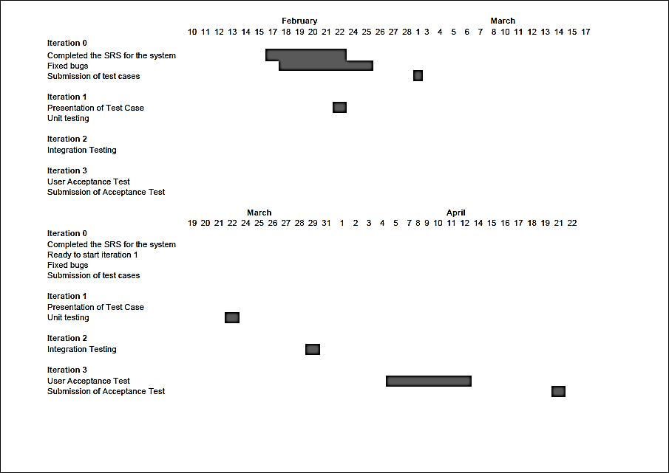

## **Planning Risk and Contingencies**

* + The system was very dependent on an internet connection.
  + The tracking system will be hosted by our professor and the only downfall that we see in this project is that, whenever the server is down. The service will also be down. It would stop the productivity of the user.
  + This problem can addressed through having two server which would host the site. Whenever the server was down. There would always be another backup. It would up to the client to accept the proposition.

## **Approval**

|  |  |  |
| --- | --- | --- |
| **Mr. Joe Gene Quesada**  Course Professor |  | **Ms. Vicky Borres**  Project Sponsor |
| **John Edward Delos Reyes**  Project Manager |  | **Neil Patrick Cheng**  Database Manager |
| **Karl Anthony Fernandez**  Documentation Manager |  | **Clark Jessan Lubrio**  Layout Manager |